Title/Author: Gilberto and the Wind by Marie Halls Ets
Suggested Time to Spend: 5 Days (Recommendation: two sessions per day, at least 20 minutes per day)
Common Core grade-level ELA/Literacy Standards: RL.K.1, RL.K.2, RL.K.3, RL.K.4, RL.K.7; W.K.2, W.K.8; SL.K.1, SL.K.2, SL.K.3, SL.K.4, SL.K.5, SL.K.6; L.K.1, L.K.2, L.K.4, L.K.5, L.K.6
Lesson Objective:
Students will listen to an illustrated fictional text to understand the effects of wind.

Teacher Instructions
Before the Lesson
- Read the Big Ideas and Key Understandings and the Synopsis below. Please do not read this to the students. This is a description to help you prepare to teach the book and be clear about what you want your children to take away from the work.
Big Ideas/Key Understandings/Focusing Question
What can wind do? One key takeaway is that when the wind blows, many things can happen and it can affect us in many ways (both positive and negative).
Synopsis
In this piece of fiction, a boy named Gilberto makes Wind his playmate. Along the way, Gilberto discovers that the wind can be an unpredictable playmate. Sometimes it helps him sail his toy boat, catch apples that fall from the trees, and spin his pinwheel. Other times, it keeps him from flying his kite or raking leaves. In the end, he and the wind affirm their special bond.

- Go to the last page of the lesson and review “What Makes This Read-Aloud Complex.” This was created for you as part of the lesson and will give you guidance about what the lesson writers saw as the sources of complexity or key access points for this book. You will of course evaluate text complexity with your own students in mind, and make adjustments to the lesson pacing and even the suggested activities and questions.
- Read the entire book, adding your own insights to the understandings identified. Also note the stopping points for the text-inspired questions and activities. Hint: you may want to copy the questions vocabulary words and activities over onto sticky notes so they can be stuck to the right pages for each day’s questions and vocabulary work.

Note to teachers of English Language Learners (ELLs): Read Aloud Project Lessons are designed for children who cannot read yet for themselves. They are highly interactive and have many scaffolds built into the brief daily lessons to support reading comprehension. Because of this, they are filled with scaffolds that are appropriate for English Language Learners who, by definition, are developing language and learning to read (English). This read aloud text includes complex features which offer many opportunities for learning, but at the same time includes supports and structures to make the text accessible to even the youngest students.
This lesson includes features that align to best practices for supporting English Language Learners. Some of the supports you may see built into this, and /or other Read Aloud Project lessons, assist non-native speakers in the following ways:

- These lessons include embedded vocabulary scaffolds that help students acquire new vocabulary in the context of reading. They feature multi-modal ways of learning new words, including prompts for where to use visual representations, the inclusion of student-friendly definitions, built-in opportunities to use newly acquired vocabulary through discussion or activities, and featured academic vocabulary for deeper study.
- These lessons also include embedded scaffolds to help students make meaning of the text itself. It calls out opportunities for paired or small group discussion, includes recommendations for ways in which visuals, videos, and/or graphic organizers could aid in understanding, provides a mix of questions (both factual and inferential) to guide students gradually toward deeper understanding, and offers recommendations for supplementary texts to build background knowledge supporting the content in the anchor text.
- These lessons feature embedded supports to aid students in developing their overall language and communication skills by featuring scaffolds such as sentence frames for discussion and written work (more guidance available here) as well as writing opportunities (and the inclusion of graphic organizers to scaffold the writing process). These supports help students develop and use newly acquired vocabulary and text-based content knowledge.

The Lesson – Questions, Activities, and Tasks
Questions/Activities/Vocabulary/Tasks | Expected Outcome or Response (for each)
FIRST READING:  Read aloud the entire book with minimal interruptions. Stop to provide word meanings (clothespins, pasture, pinwheel, meadow, etc.) or clarify only when you know the majority of your students will be confused.  Activity: After the first reading, have each student create two sticks to represent Wind being strong and Wind being gentle. See clip art at the end of lesson for samples.  Note: you may want to make a couple of extra puppets while your students work so absent students will have them to use during subsequent lessons. | The goal here is for students to enjoy the book, both writing and pictures, and to experience it as a whole. This will give them some context and sense of completion before they dive into examining the parts of the book more carefully.
SECOND READING:  Prior to reading, be sure each student has two stick puppets, one of Strong Wind and one of Gentle Wind.  Reread pages 4-5  What does the word gentle mean?  What words or clues in the illustration help the reader understand the word gentle?  What happened on page 5 that shows Wind being strong?  Activity: Have the students practice raising the appropriate stick when reading the sentences; “Wind is gentle and floats my balloon” and “With a jerk, he grabs it away.”  Reread pages 6-9.  Tell students as you read you want them to listen for when Wind is being gentle and when Wind is being strong and hold up the appropriate puppet based on what is happening.  Questions:  Using pages 6-9, identify at least two examples of Wind being strong.  What are some examples of Wind being gentle?  ** (The two questions above will be repeated each time you reread a chunk of text.)  Page 6: Wash usually means the act of cleaning clothes, dishes, cars. What is the author referring to when she uses the word wash on this page?  Page 8: The author refers to Wind as a person. When the author refers to Wind as a person, he is letting the reader know that Wind is a character in this story. What examples from the text tell the reader that Wind is a person?  Page 9: How does the illustration on page 9 help you understand what the word “unlatched” means?  What are some other words the author could have used instead of “unlatched”? (Pg. 9) | Gentle means mild or soft. The author describes the balloon as floating around and the illustration shows the balloon just floating in the air. This all helps the reader to understand what the word gentle means.  The text mentions that the wind then jerks and grabs the balloon away and carries it to the top of the tree. The word jerk explains that the wind was strong.  Note: Students may disagree about whether the actions of Wind are strong or gentle as many of the actions are implied. Allow students to justify their response if necessary. (This will be repeated as you continue to reread sections of the text).  Students will turn and talk to a partner to discuss what they heard as examples of strong wind and gentle wind. If students struggle with this provide sentence frames for them. For example: The wind was strong when _____. The wind was gently when___.  Begin a T Chart to categorize examples of Wind being strong and Wind being gentle. See sample.  The word wash is used to describe the clothes and linens on the clothesline. It is used as a thing not an action.  The text shows Wind is a character because Wind is always spelled with a capital letter, like the name of a person.  The pronoun “he” is used when referring to Wind.  The author refers to Wind as a character in the story who is purposely playing with Gilberto. (In some versions of the story, the illustrations show Wind as having human characteristics such as eyes, ears, nose, and mouth).  The illustration shows that the gate is open and not latched or closed.  Other words the author could have used are open, ajar, unlocked, undone, not closed.  Students can practice acting out latched and unlatched using their hands.
  Gentle Wind | Strong Wind
  floats balloon | jerks and grabs it out of the boys hand
  blows pillow slips into balloons | pulls out clothes pins
  shakes sheets | breaks umbrella
   | bangs the gate shut
THIRD READING:  Be sure each student has two stick puppets, one of Strong Wind and one of Gentle Wind.  Reread pages 10-17  Using the procedures established during the second reading, have students hold up the appropriate stick puppets as the teacher re-reads pages 10-17.  Questions:  What were some examples of Wind being strong from the pages 10-17? What are some examples of Wind being gentle?  Page 12-13 How does the wind help the big boys fly their kites?  What happens when Gilberto tries to fly his kite?  Why does Gilberto say to Wind, “I don’t like you today”?  Page 15: On page 15 it says, “And when I have a boat with a paper sail Wind comes and sails it for me –.” What are the two different meanings of the word sail on this page?  Page 17: What does the author mean when he states that Wind will make the pinwheel “whistle and sing”?  FOURTH READING:  Be sure each student has two stick puppets, one of Strong Wind and one of Gentle Wind.  Reread Pages 18-23  Using the procedures established during prior readings, have students hold up the appropriate stick puppets as the teacher re-reads pages 18-23.  Questions:  What were some examples of Wind being strong from the pages 18-23? What are some examples of Wind being gentle?  Page 18 Why does Gilberto think the Wind likes soap bubbles?  Page 21 What does scatters mean? What clues in the illustration and the words on this page help the reader figure out the meaning of scatters?  Page23 In the beginning of the story, Wind says “You-ou-ou” because he wants the boys to come out to play. On this page Wind says something different. What does Wind say, and why? (Page 23)  Look back through this story, focusing on the illustrations. Does this story take place in one day or over several days? Explain your answer with evidence from the illustrations and text. | Have students share with a partner prior to sharing as a class. Provide sentence frames if necessary (See Second Reading).  Chart continued...  Wind helps the big boys out as it “carries their kites way up to the sky and all around.” The wind actually helps them fly their kites.  Wind drops the kite when Gilberto tries to fly his kite.  Gilberto says he doesn’t like Wind today because Wind won’t fly Gilberto’s kite at all.  The first sail means a part of a boat. The boy refers to his boat as having a paper sail.  The second meaning of the word sail is to move across water because the author states that Wind “sails big sailboats on the sea.”  The author means that the pinwheel is moving so fast it is making noise that sounds like a person whistling and singing. (Teacher can discuss with students how the author gives both Wind and the pinwheel human traits.)  Have students share with a partner prior to sharing as a class. Provide sentence frames if necessary.  Continued from previous charts.  Gilberto thinks Wind likes the soap bubbles because Wind carries the bubbles up into the air and then blows them back to him. Gilberto obviously likes it when Wind does this because he laughs and thinks Wind finds it fun too.  Scatters mean to separate and go in different directions. The illustration shows the leaves thrown about in different directions and the words say “scatters the leaves all about again.”  Wind is saying “Sh-sh-sh-sh”. Wind is tired and wants to go to sleep.  The story takes place over several days because some days are windy, some days are rainy, and some days are sunny. The story must take place at least over 12 days because Gilberto wears 12 different outfits.
  Gentle Wind | Strong Wind
  Continued...
  flies a kite | makes a pinwheel whistle and blow
  sails a boat | blows apples to the ground
  Gentle Wind | Strong Wind
  Continued...
  carries soap bubbles into the air | scatters leaves
   | blows dirt in faces
   | breaks trees
   | knocks down fences
FIFTH READING:  Teacher will read the text in its entirety. Students can use their puppets as done in the previous reads.  Review completed T Chart.  Activity: Using the clip art, students will sort pictures of strong Wind and Gentle Wind in small groups. Talk in groups about what in the story helped you decide if Wind was strong or gentle. Students can place the pictures on a graphic organizer similar to a T chart.  After the sorting activity, bring students back together.  Activity: To prepare students for the culminating task, students will play Mix-Pair-Share.  1. Give each student one graphic.  2. Students will stand and find a partner. Each partner will use their graphic in a sentence such as “Apples fall from trees when the wind is strong.”  3. Once both partners have shared their graphic by using it in a sentence, they will exchange graphics and find a new partner. | Clip art for this activity are included with the lesson. As students sort the pictures, the teacher can circulate and listen to their discussions.  This activity encourages active participation and an opportunity for students to orally rehearse prior to completing the culminating activity.
  Gentle Wind | Strong Wind
  floats balloon | jerks and grabs it out of the boy’s hand
  blows pillow slips into balloons | pulls out clothes pins
  shakes sheets | breaks umbrella
  flies a kite | bangs the gate shut
  sails a boat | makes a pinwheel whistle and blow
  carries soap bubbles into the air | blows apples to the ground
   | scatters leaves
   | blows dirt in faces
   | breaks trees
   | knocks down fences

FINAL DAY WITH THE BOOK - Culminating Task
- Think about the experiences Gilberto had with Wind. Using the T Chart, discussions, and your drawings/notes choose one example of Wind being gentle and one example of Wind being strong. Draw and write about each example by completing the sentence “Wind is gentle when ___.” “Wind is strong when ___.” When you are done you will share your writing and drawing with a partner using complete sentences.
  - Sample answer: Wind is gentle when it floats balloons in the air. Wind is strong when it bangs gates shut.
  - (Students’ drawings should clearly match the writing. If students struggle with writing be sure to take dictation so you know whether they are at least able to recall examples of strong and gentle wind.

Vocabulary
These words merit less time and attention  (They are concrete and easy to explain, or describe events/  processes/ideas/concepts/experiences that are familiar to your students.) | These words merit more time and attention  (They are abstract, have multiple meanings, and/or are a part  of a large family of words with related meanings. These words are likely to describe events, ideas, processes or experiences that most of your student will be unfamiliar with)
Page 5 – gentle – not rough, severe, or violent  Page 5 − whisper−to speak with soft, hushed sounds  Page 7 − clothespins − a device, such as a forked piece of wood or plastic, for fastening articles to a clothesline  Page 9 − pasture − an area covered with grass  Page 10 – meadow – flat area of land with tall grass  Page 14 – ripe – having arrived at such a stage of growth or development as to be ready for eating  Page 17 − pinwheel − a child’s toy consisting of a wheel or leaf-like curls of paper or plastic loosely attached by a pin to a stick, designed to revolve when blown by or as by the wind. | Page 5 − jerks − a quick, sharp pull, thrust, twist, throw; a sudden movement  Page 5 − floats − to move lightly and gracefully; to rest or remain on the surface  Page 9 − unlatched − to unfasten  Page 15 − sail, sails − a voyage or excursion; an area of canvas extended to the wind in such a way as to transmit the force of the wind to move it  Page 17 − blur − not clear or blurry  Page 22 − howling − producing or uttering a howling noise  Page 21 − scatters − to throw loosely about; to separate and drive off in various direction; disperse  Page 23 − stirs − to move one’s hand repeatedly in order to mix any or all of the components; to set in tremulous, fluttering or irregular motion

Extension learning activities for this book and other useful resources
- We learned that the word unlatched means not latched or not closed. When we see the prefix un in front of a word, it changes the meaning of the word because un means not. Add the prefix un to the following words and discuss how the meaning has changed: happy, dressed, covered, buttoned, clear, fair, zipped, tied, and done. Note: This is particularly supportive of English Language Learners.
- Bring a fan or two into the classroom. Give students a variety of objects to gently drop in front of the blowing fan (feather, block, paper, shoe, etc.) Have the students chart how the various objects behave when placed in the ‘wind’.
- Remind the students how Wind enjoyed blowing the wash on the clothes line. Explain that they are going to play a Smartboard game called “clothesline”. Draw a straight line across the Smartboard/whiteboard and draw a variety of simple “clothes” hanging from it. Inside each piece of clothing, write a letter sound or consonant blend found in the text. Have students think of words that start with those sounds and then go up to the board to blow it away by erasing it as they say it. Repeat with new sounds/letters.

Note to Teacher:
- Teacher can use the attached clip art when creating the T Chart organizer. This will help students be familiar with the pictures before they complete the sorting activity.

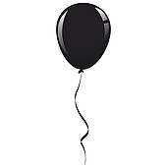 | 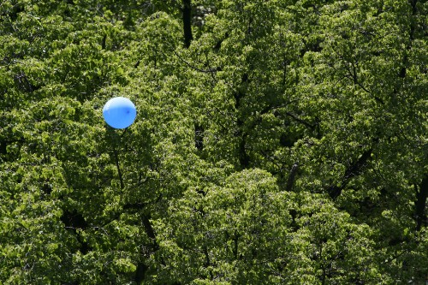
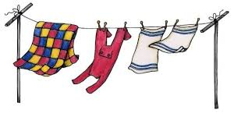 | 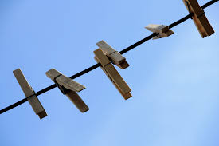
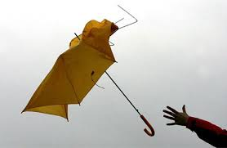 | 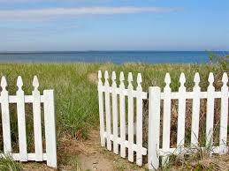
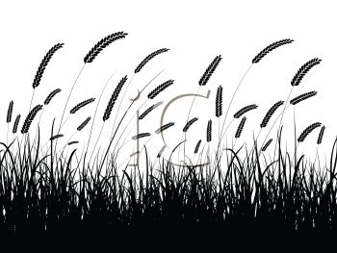 | 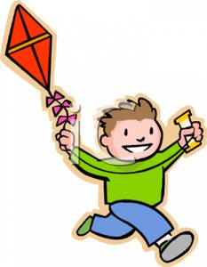
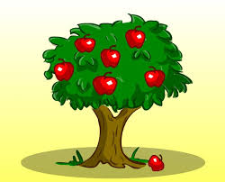 | 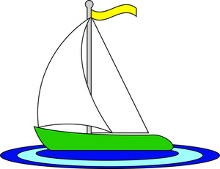
 | 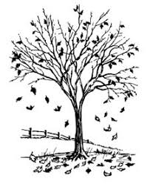
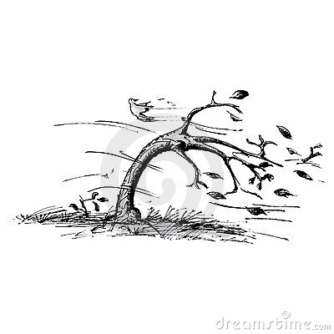 | 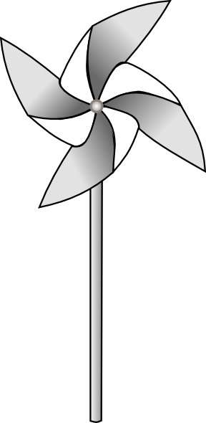

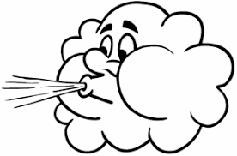  Gentle Wind | 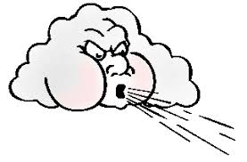  Strong Wind

Samples of Gentle Wind and Strong Wind for reading activity

What Makes This Read-Aloud Complex?
- Quantitative Measure
Go to http://www.lexile.com/ and enter the title of your read-aloud in the Quick Book Search in the upper right of home page. Most texts will have a Lexile measure in this database.

Most of the texts that we read aloud in K-2 should be in the 2-3 or 4-5 band, more complex than the students can read themselves.
2-3 band 420-820L
4-5 band 740-1010L

460L

- Qualitative Features
Consider the four dimensions of text complexity below. For each dimension, note specific examples from the text that make it more or less complex.

- Multiple levels of meaning: wind as weather, wind as a character, effects of wind through seasons
- Implicit Meaning: wind tries on clothes, wind runs ahead, seasons are implied in the illustrations
- Illustrations are essential to meaning: Wind is a person, pg.4,
- Structure: series of events over time are implied through the illustrations, not specifically stated

Figurative language: personification (pg 7 wind tries on clothes though they are too small) onomatopoeia (“you-ou-ou”)
Vocabulary: whisper, floats, gentle, wash, sail, sails, scatters, unlatched, pasture, meadow, jerk, howling

Students may need background knowledge on:
- Wind
- Weather/seasons
- Kites/ pinwheels, sailboat

Meaning/Purpose
Structure

Language
Knowledge Demands

*For more information on the qualitative dimensions of text complexity, visit http://www.achievethecore.org/content/upload/Companion_to_Qualitative_Scale_Features_Explained.pdf

- Reader and Task Considerations
What will challenge my students most in this text? What supports can I provide?
Figurative Language structures and vocabulary will be challenging, particularly in reference to the role of Wind in the text. Support using repeated readings, questions to clarify word meanings and careful attention to how the illustrations and text connect. Build opportunities for active engagement…

How will this text help my students build knowledge about the world? This lesson will be part of a unit on Wind and Weather. By reading this text, students will build upon their knowledge of wind and how it affects us.

- Grade level:
What grade does this book best belong in? Kindergarten

All content linked to within this resource was free for use when this resource was published in March 2018. Over time, the organizations that manage that external content may move or remove it or change the permissions. If the content is no longer available, please email info@studentsachieve.net.

